**INDUSTRIAL TRAINING REPORT**

Name: Rajorshi Ghosh

College: Future Institute of Engineering and Management

Training details: Node JS Training from Internshala Trainings

Training Duration: 6 weeks

Project Name: MongoDB CRUD App

MongoDB CRUD App

This web application demonstrates the Create, Read, Update, Delete (CRUD) and search operations on MongoDB database using AJAX requests connected via a Node server running Express framework. This application can be used to digitally store singular data values with each a unique ID to track.

This application was developed as a part of industrial training provided by Internshala.

**Aim:**

To demonstrate CRUD operations on MongoDB using an express webapp.

Characteristics:

* Platform Independent
* Large Storage
* Cloud Database

Programming Languages used:

* HTML
* CSS
* JavaScript

Framework used:

* ExpressJS

Database:

* MongoDB

Server:

* NodeJS

**Features:**

1. Read records:  
   On visiting the website the user will connect to the online **MongoDB** database and see this screen.   
     
   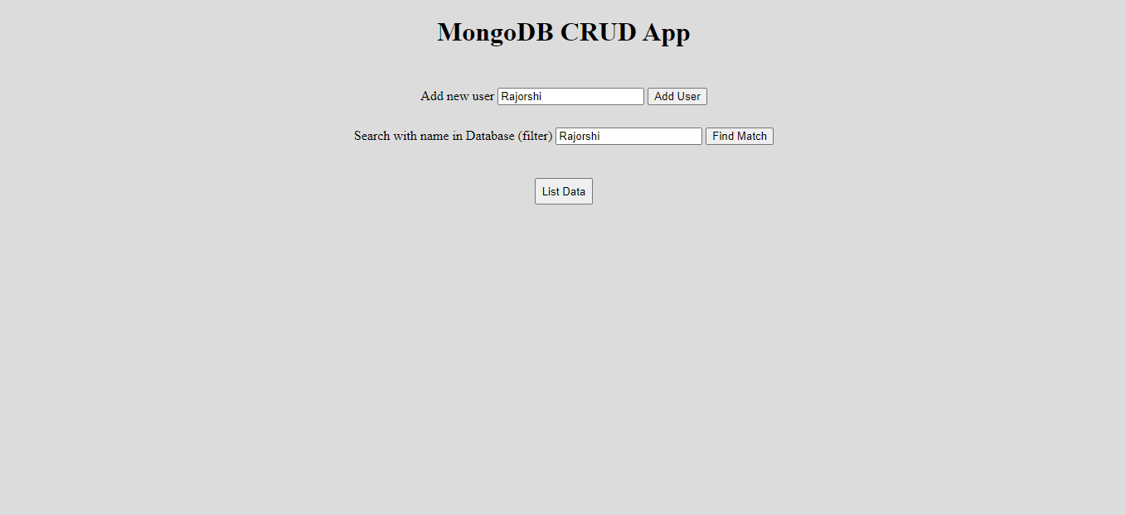  
     
   If the user clicks the “List Data” button a **fetch request** will be sent to get the existing records from the Database and will be **dynamically rendered** below on the page.  
     
   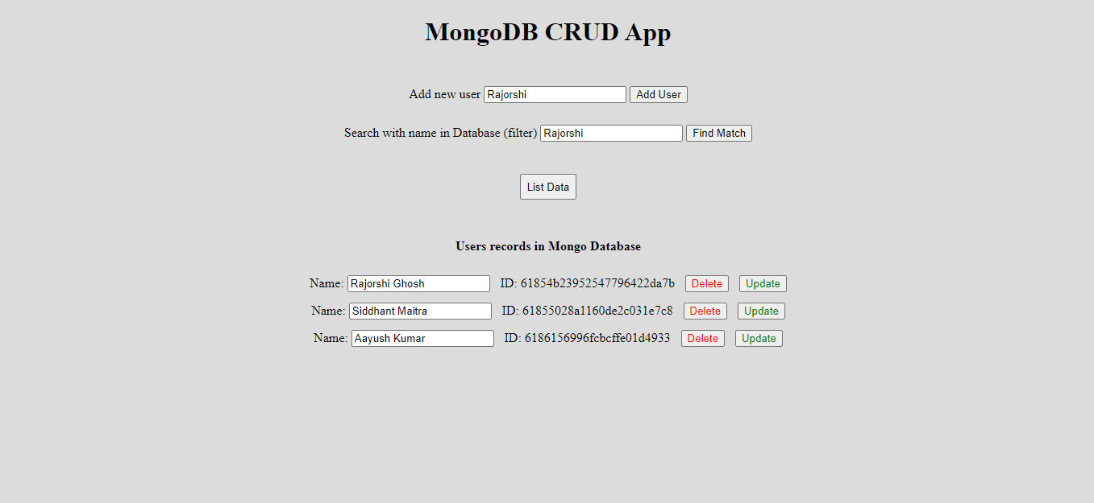
2. Create a record:  
   The app provides the user with an input field beside “Add new user” caption to enter the new record name and “Add User” button beside it to add it to the database.  
   After adding a record the user must press “List Data” button to observe the new record being added to the list.  
     
   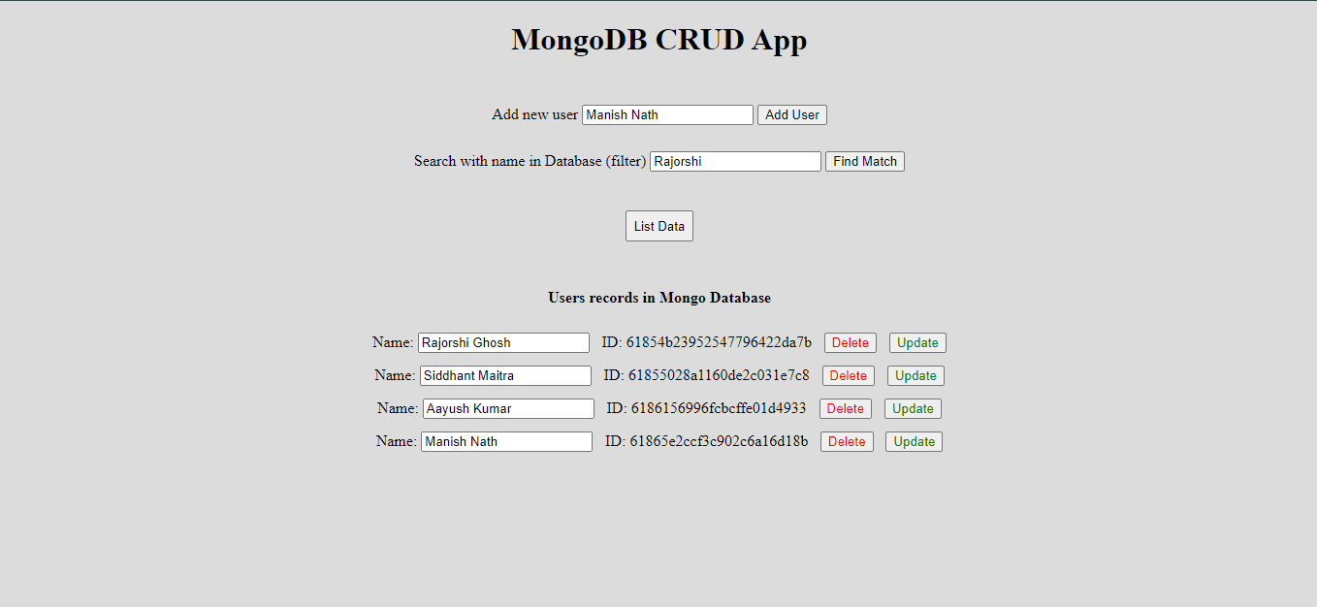
3. Search for a record:  
   The user can search for any specific record by entering the name details in the input field beside “Search with name in Database” caption and pressing the “Find Match” button beside it. If the record/s is found in the database they will be displayed below.  
     
   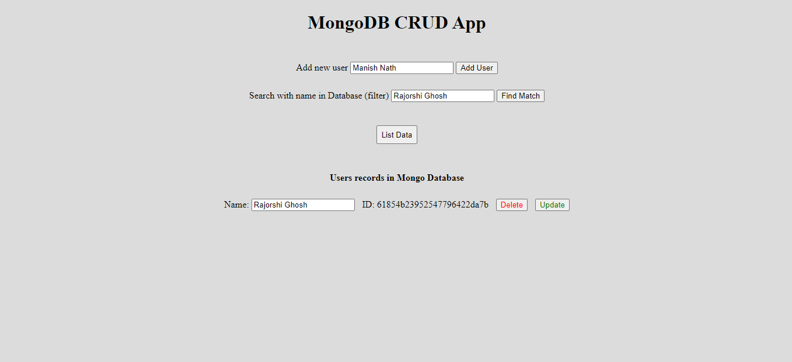
4. Updating a record:

Any record can be updated by the user by editing the current record name shown in the input field of the record beside “Name:” caption.

To update with the new value the user must press the “Update” of the record of work. The user can list all data again to confirm their updating.

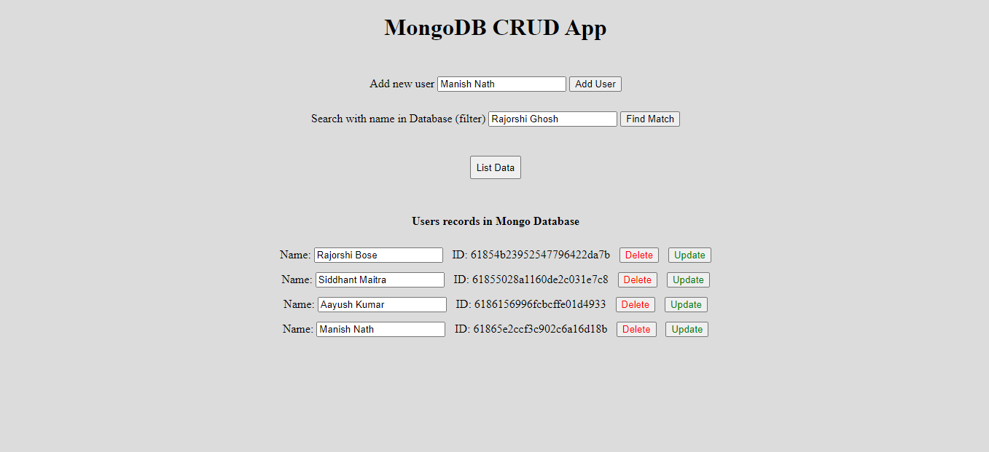

1. Deletion of record:

Any record can be deleted from the database by the user by clicking the “Delete” button of the record. The user can list all data again to confirm their deletion.

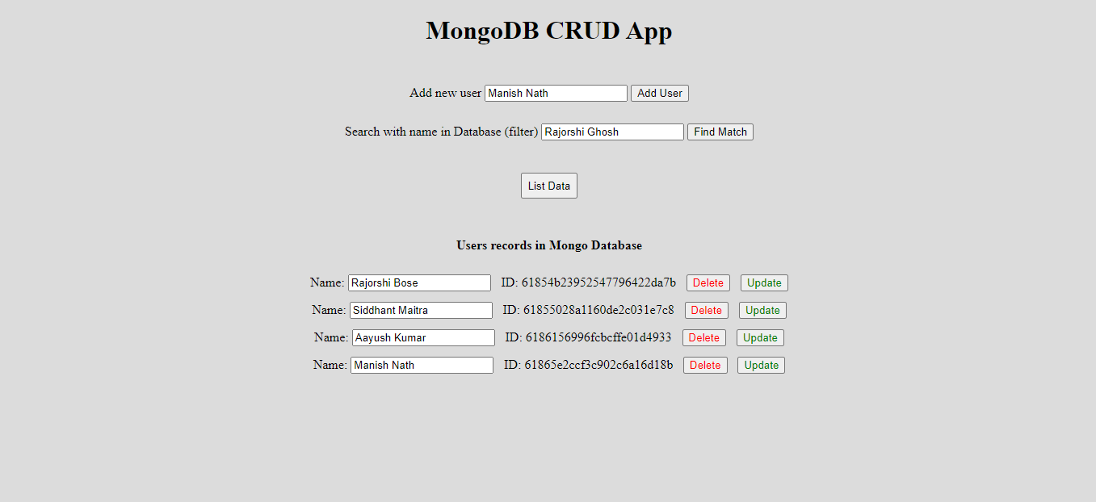

**Future Scope:**

Few improvements can be done on this web application to make it more feature rich in future.

Some of the points are mentioned below:

1. At present the web application is running on on-premise servers. In near future the web application can be deployed on cloud to make the application more scalable and faster.
2. For designing, Bootstrap/Tailwind CSS framework can be used to make it look more pleasing and user friendly.
3. One can optimize the client-side scripting code with the help of React/Angular framework.

**Conclusion:**

The Application successfully focuses on Back-End development and exhibits the basic functionalities of interacting with a database and has room for improvements and utilizing technologies learnt through out this training more full-fledged applications using similar tech-stacks can be developed.